Feasibility Report:

1.Introduction:

1. Overview of project:

This project intent to the auto-generation of 3D models from 2D imported floor plans. It can be operated by importing a 2D floor plan in an image format. The techniques of image processing and model mapping used to generate the 3d computer graphics model according to the imported 2D floor plan. The 3D modification function provides ability to change the texture of floor and walls; moreover, it also enables users to add furniture in 3D constructed model. User can look at 3D model from different viewpoints i.e. top-view, walk-through, front-view and side-view.

1. Background
2. Motivation

A common user or an artist who does not know how their home look after construction and proper adjustment of their accessories, it’s a big platform for them to see their house in 3D more than their imagination. We move towards this project because many artists, civil constructors and common house owners which want houses according to their own designs, so to help them that their floor plan will look good or not after implementation, we are making this software. Already existing such systems can only used by technical users because a lot of manual work is required to construct 3D model from 2D file format. So, this motivates us to automatically generate 3D model from an imported 2D floor plan image by just clicking a button.

2.Objectives of the project:

1. Industry Objectives
2. Research Objectives
3. Academic Objectives

3.Scope of the project

4.Target Audience

* **Common Users**

People of this era are full of wishes, they want their own designs to construct and adjust their houses. Our software will enable common users to visualize 3D model according to their own choice of 2D floor plan. Avery easy to use GUI enables common users to do interior design of home.

* **Interior Designers**

Our software helps interior designers in quick editing of 3D model without even wasting essential resources i.e. time and money.

* **Architects and Home planners**

For architects or planners who are making floor plans for common people, this 3D software provides them ease and makes them to do less effort for customer satisfaction and increases the quality of their service delivery in time. So, our software can also be used by architects and home planners.

* **Real estate sellers agents**

For people who are running real estate businesses, 3D floor plans could bring new ideas for efficient sales promotions. It could help them engage customers with interactive and informative site details of adjustment. So, our software can also be used by real estate agents.

5.Possible Applications of work

6.Existing System

1. Comparison of Existing Systems

|  |  |  |  |  |  |  |  |  |
| --- | --- | --- | --- | --- | --- | --- | --- | --- |
| Softwares | Developed By/ Company | Key Features | Type of Software | Platform Supported | Backend-Technology | Deployment | Difficulty Level |  |
| SketchUp | Brad Schell,  Trimble Inc. | 2D drawing, 3D Modelling, Panoramic 360 Views, Parrametric Model, Textures | Freemium | Windows and Mac | Written in C++ & Objective-C. Open GL is used as a display layer. | Open API  But for in-process apps. Used as extension of SketchUp | Average |  |
| SweetHome3d |  | 2D drawing, 3D Modelling, Panoramic 360 Views, Parrametric Model | Free and open source | Linux, Mac OS X, Solaris and Windows | Written in Java. Java3D is used for graphics. | Open API | Easy |  |
| Blender | Ton Roosendaal | * Rendering. * High-End Production Path Tracer. * GPU Rendering, * Game Creation, * Animation Toolset. * Fast Rigging, * Visual Effects. * Camera and Object Motion Tracking | Free and open source | Windows, MacOS, Linux, Free BSD, OpenBSD | Written in C, game engine is mostly C++ and there is tiny bit of Python for API and included scripts.  It uses [OpenGL](https://en.wikipedia.org/wiki/OpenGL), a cross-platform graphics layer, to communicate with graphics hardware. | Open API | Difficult |  |
| Free CAD Software | Jürgen Riegel, Werner Mayer, Yorik van Havre | 2D drawing, 3D Modelling, Panoramic 360 Views, Parrametric Model | Free and open source | [GNU/Linux](https://en.wikipedia.org/wiki/Linux) [macOS](https://en.wikipedia.org/wiki/OS_X) [Unix](https://en.wikipedia.org/wiki/Unix) [Windows](https://en.wikipedia.org/wiki/Microsoft_Windows) | Written in C++, Python. The interface is built with Qt.  Its open Inventor-compliant 3D scene representation model provided by the Coin 3D library, and a broad Python API. | Open API | Average |  |
| SolidWorks | Autodesk | 2D Drawing, 3D solid Modelling, 3D model editing | Neither free nor open source but free trial version is availabele | Windows,MacOS | Written in C++ | Open Api | Difficult |  |
| HomeStyler | Autodesk | 3D drawing and modelling, Drag and drop,  Variety of textures,  Furniture Catalogue | Open Source, Free and online version to start with | Windows and Web based | Written in C++ | Open Api | Average |  |

1. Drawbacks of Existing Systems

* SketchUp:

SketchUp is commonly used by architects, civil engineers and mechanical engineers for the purpose of architectural design. This software mainly focuses on the design of architectural building ad less focus on interior design. So this software is not suitable for interior design. This software cannot generate 3D model automatically. It required a lot of manual work in creating 3D model. For example before generating 3D model, users must trace the floor plan image and then extrude the walls by using SketchUp provided tools. So, it is not easy to use for non-technical users.

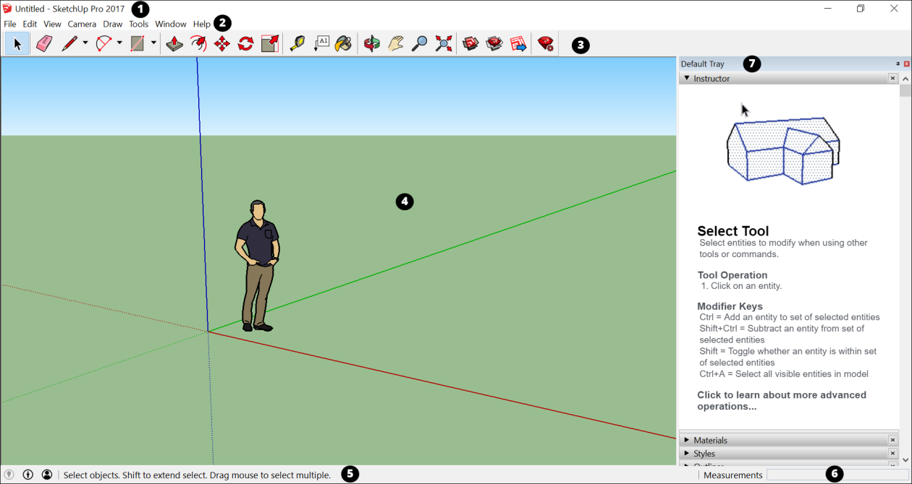

* SweetHome3d:

SweetHome3d mainly focuses on generating 3D model by drawing 2D floor plan in provided editor simultaneously. If user wants to generate 3D model by importing floor plan image then manual work of tracing and refining an image is required. So, a lot of time is required in doing so.

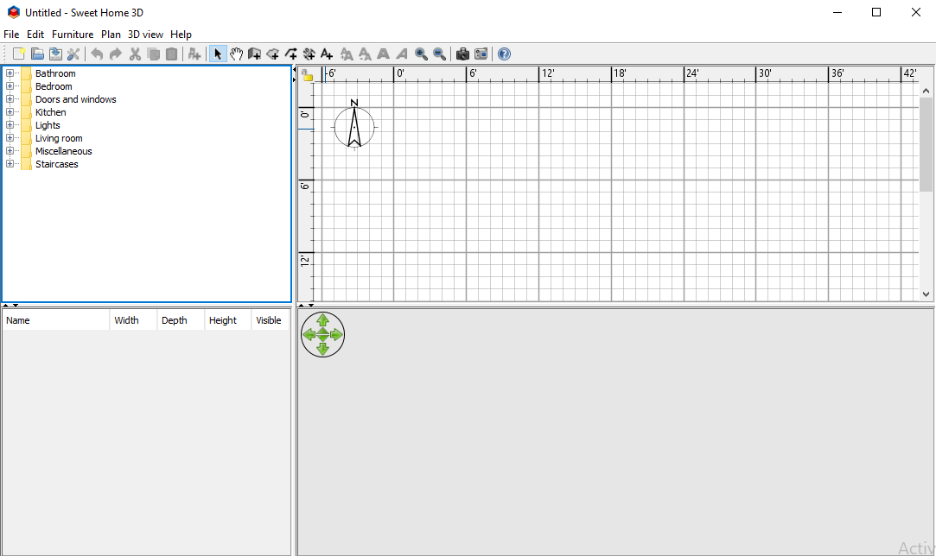

* Blender:

Blender is a big platform for modeling, animation, simulation, and game creation. It is very difficult to use because of 100% customizable interface. It is suitable only for technical users. It requires a lot of effort and time to learn how to use Blender. It allows users to draw 2D floor plan and generate 3D model after a lot of manual work. So, it is not suitable for non-technical users.

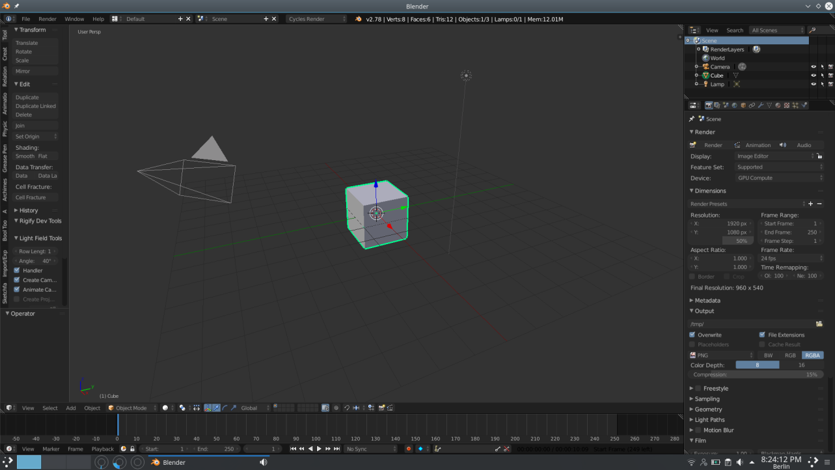

* FreeCAD Software:

We can create best 3D models through FreeCAD but the problem is again less automation and more manual work is required. Time taking process is required to know how to run the software and also training of the staff is required which will work on it. So, this software is not suitable for normal user.

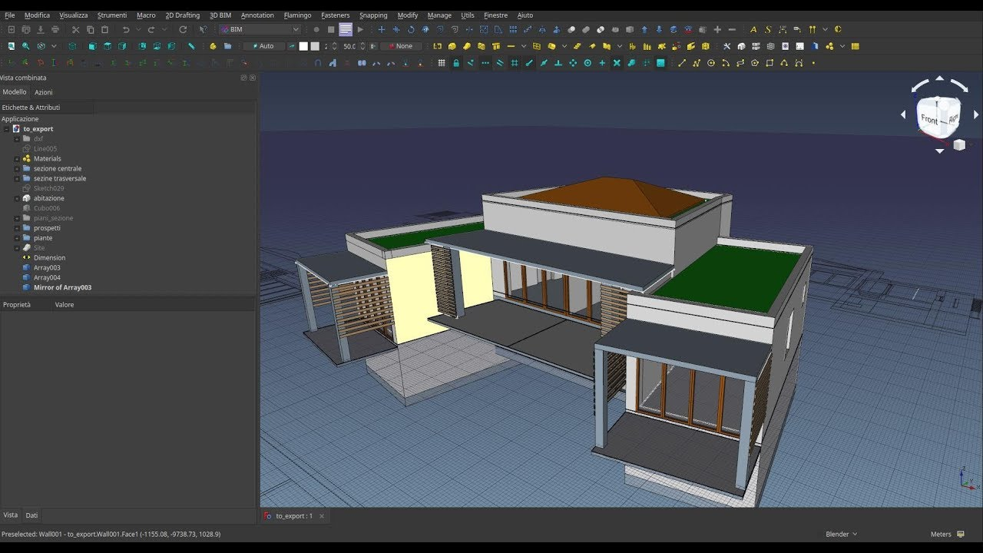

* SolidWorks:

SolidWorks mainly focuses on creating 3D models of all types. It does not specifically focus on 3D model of rooms. Although this software is relatively easy to use in comparison to other such softwares but main drawback is its pricing. Also, it is not suitable software for interior design of home.

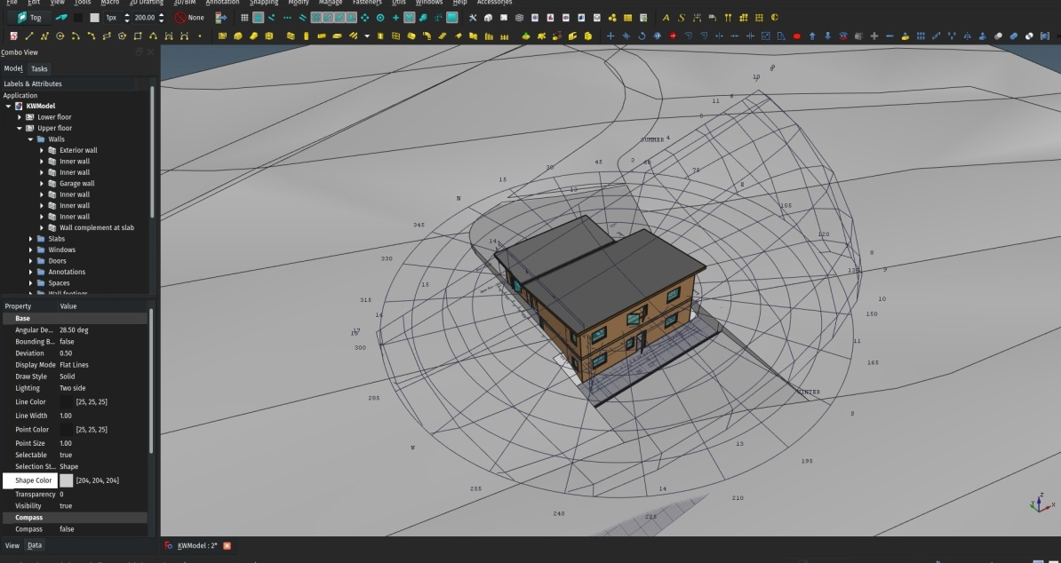

* HomeStyler:

HomeStyler is mainly focuses on interior design but the main drawback is user cannot import 2D floor plan image. User will force to make 2d floor plans in provided editor in order to see its 3D model. So, if user built 2D floor plans in some other software, he/she will not able to import floor plan in HomeStyler.

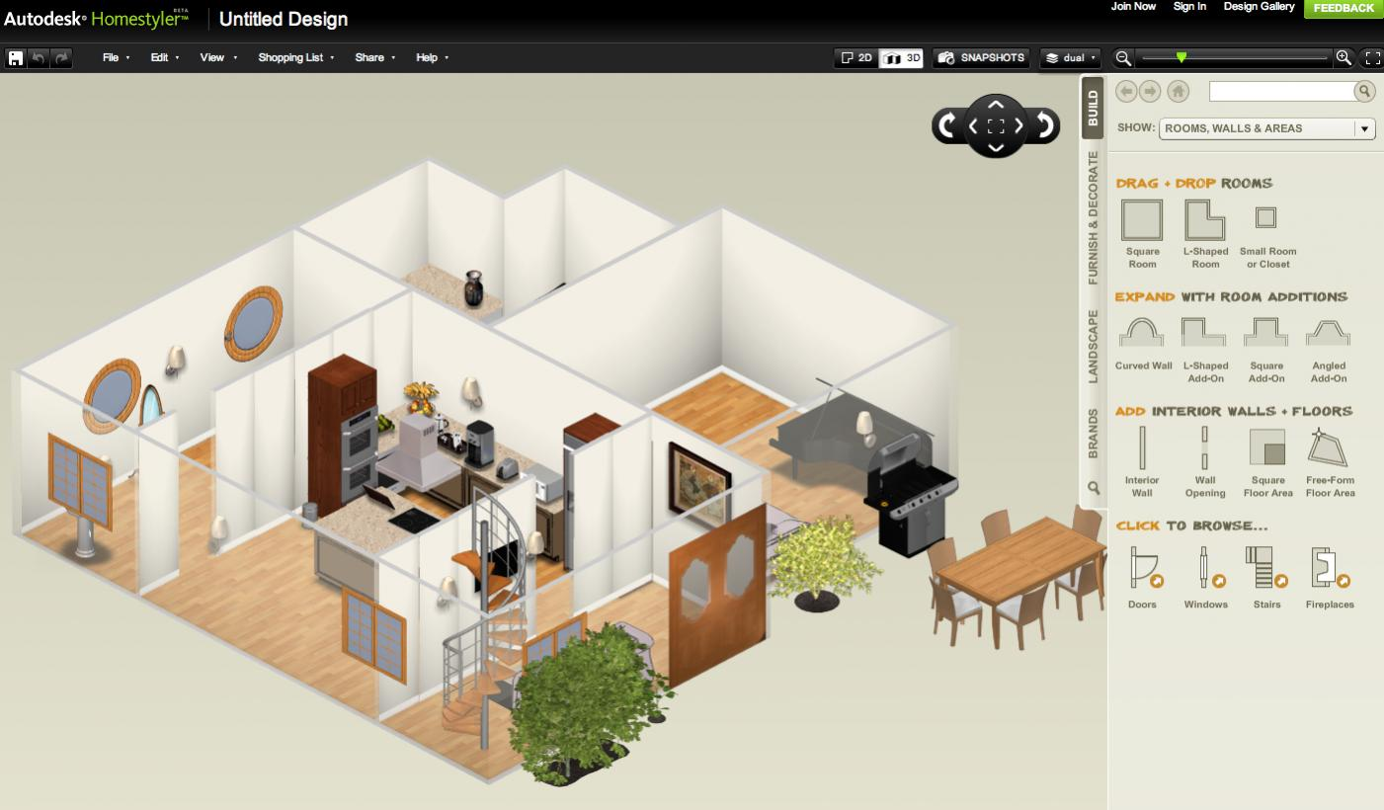

7.Problem Statement

When anyone plans to construct a new flat/house and can only see its floor plan. So it’s hard for anyone to imagine the actual environment by just seeing 2-D floor plan. So, our system will enable the users to see this 2-D floor plan into 3-D. Sometimes users also get curious how to design the interior of house. So, this system will also enable users to modify or add furniture in 3-D generated model.

8.Proposed System

9.Feasibility Study

1. Technical feasibility
2. Operational feasibility
3. Economical feasibility

10.System Requirements

1. Hardware Requirements
2. Software Requirements

11.Limitations and challenges in implementation of project

12.References